LAB #2 — REPORT

30 points possible

All materials must be uploaded to Gradescope by 10 am on Tuesday, February 8 2022 (check Brightspace for updates on due date)

NAME: Kris Laferriere

At the end of the lab, you should have created the following files in your working directory:

- This report, edited and filled out

- Copies of your journal files

- imp_histogram.png

- imp_stretched.tif

- imp_sky_histogram.png

- imp_masked.png

- imp_bb_histogram.png

- imp_bb.tiff

- imp_sky.tif

- juno_red_no_bad_pixels.tif

- replace_bad_pixels.pro

Min, max of av_img: 0, 0.274653

1. (a) Paste “imp_histogram.png” below (1 pt).

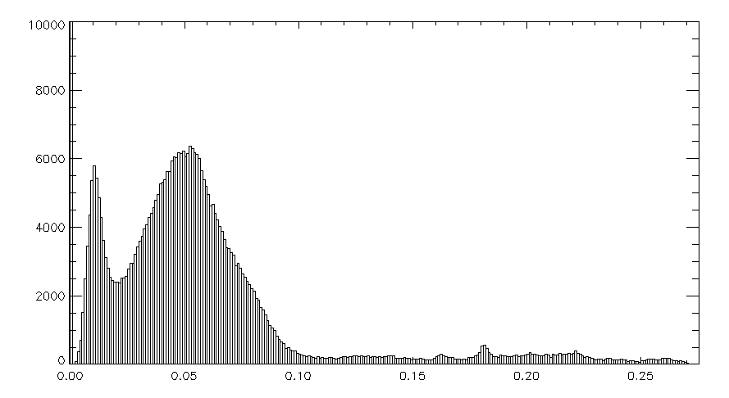

Black bkground: 0 values

Shadows: 0.02

Surface, everything up to 0.1

Sky: above 0.1

(b) What is the range of values that correspond to the following parts of the scene? (1 pt)

- the black background:

- the shadows:

- the surface:

(c) Paste “imp_stretched.tif” below. (1 pt)

Stetched 0.02, 0.1.



(d) Paste “imp_sky_histogram.png” below (1 pt).

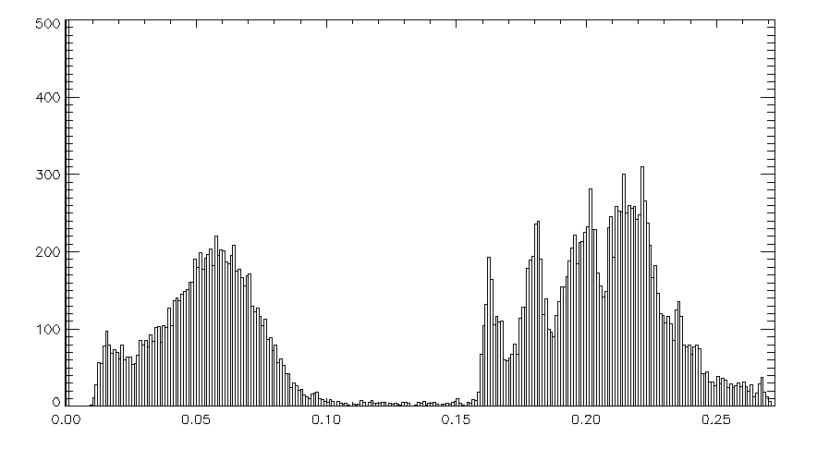

(e) In the av_img array, what is the approximate range of values in the sky? (1 pts)

Sky is greater than 0.15. crop had some rock/surface in it.

2. (a) Paste “imp_masked.tif” below (1 pt).



(b) Paste “imp_bb_histogram.tif” below (1 pt)

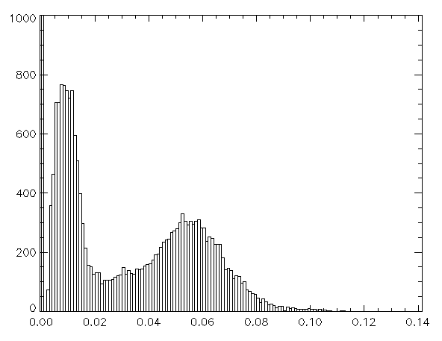

(c) What limits will you use to illuminate the shadowed region and why? (2 pt)

0-0.02, gets the first peak

(d) Paste “imp_bb.tiff” below (1 pt)



(e) What is in the darkest part of Barnacle Bill’s shadow? (1 pt)

Right under the rock.

In the shadow are rocks that are smaller.

Darkest values are 0.002.

3. (a) How many pixels are in the valid image portion of av_img? That is, not counting the black background. (1 pt)

Number of pixels = 369456

(b) How did you isolate the sky? Please be specific and detailed as you describe your method. (2 pts)

Make everything away from sky = 0, make everything below sky # equal to zero.

IDL> mask = fltarr(612, 768)

IDL> mask[where(av_img gt 0.001)]=1

IDL> mask[where(av_img[0:611, 0:500])]=0

IDL> atv2, mask

IDL> mask[where(av_img[0:611, 0:700])]=0

IDL> mask[where(av_img lt 0.1)]=0

IDL> atv2, mask

IDL> atv2, mask*av_img

(c) How did you remove the other bright (non-sky) objects at the bottom of the scene from the mask? (2 pt)

(d) How many pixels represent the sky in av_img? (1 pt)

Number of sky pixels = 14760

(e) What percentage of the image is the sky (i.e., (number of sky pixels) / (number of valid image pixels) * 100)? (1 pt)

Answer: The sky is % of the image.

(e) Paste ”imp_sky.tif” below. (1 pt)



4. (a) How does changing the width of the median filter to a larger value affect the image? (1 pt)

Changing the width (original 3). Increasing makes the differences harder to see, brings up the auto max. higher numbers are worse.

(b) *In words,* what is your definition of a bad pixel? Will this definition work for most images, or is it unique to this image? (2 pts)

Typical in cometary, outside 2 sigma where sigma is a std. a bad pixel is significantly different than the mean. For this image, there are pixel which differ from the mean more than others (diff = 0.4 rather than 0.1).

bad_pixel=where(juno_diff gt 2*stdev(juno_diff))

gives 17928 of 2560000 == 0.7%.

even adjusting to 3 sigma doesn’t fix the outliers.

(c) How many "bad" pixels did you find in each of the six raw images? For reference, I replaced about 1% of the pixels with noise. How does your number of bad pixels compare to this? (1 pt)

(d) Critically evaluate your corrected image. Did you remove all of the obvious bright *and* dark bad pixels? Compare to the original image - do you see any evidence that you “over-correct” in some way (replaced apparently good pixels)? (2 pts)

No, some of the ones off Jupiter escaped. Bright ones anyways, all dark seem fixed.

(e) Paste “juno_red_no_bad_pixels.tif” below. (1 pt)



Original



5. (a) Copy and paste your “replace_bad_pixels.pro” code below. (3 pts)

(b) Paste the corrected image you generated with your code below. (1 pt)